**Steps of work**

1. **The Database Schema**

There are three tables in the database:

* city_list - This contains a list of cities and countries in the database. Look through them in order to find the city nearest to you.

Select * from city_list

Then download CSV

* city_data - This contains the average temperatures for each city by year (ºC).
* Select * from city_data
* global_data - This contains the average global temperatures by year (ºC).
* Select * from global_data

**1-2 Importing the important Libraries**

**1-3 Importing the extracted Data Set**

**from matplotlib import pyplot as plt #for making line chart**

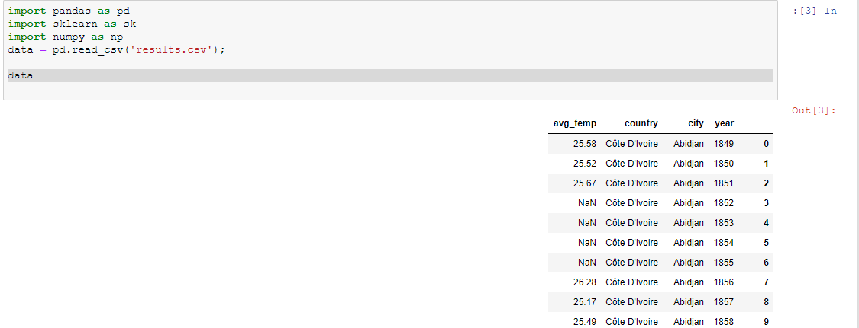

71311 rows × 4 columns

STEP 1 - Extraction of Data from provided Database

To see which cities are available for "Cairo" in the given dataset:

Note : My local city “Gaza” but there not exits s so I select

Ciro because is The nearest city instead of Gaza

SELECT *

FROM city_list

WHERE country LIKE 'Egypt'

After run this query notice:

Tow result “cairo & Alexandria”

ALTER TABLE city_data RENAME COLUMN avg_temp to CAT;

-- CAT = City Average Temp.

ALTER TABLE global_data RENAME COLUMN avg_temp to GAT;

-- GAT = Global Average Temp.

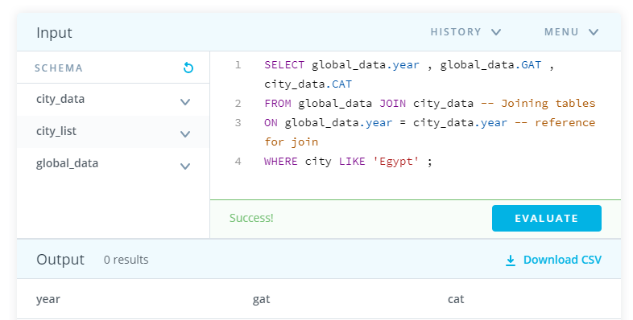

cairo=data.loc[data['country']=='Egypt']

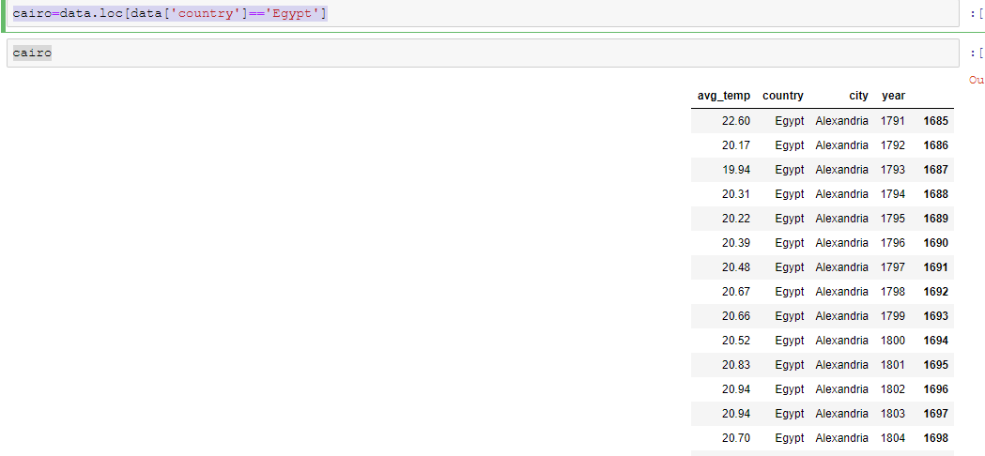 429 rows × 4 columns